Functional Specification Document

PROJECT: MVP 2 Farming Engagement Hub
EPIC: Farmer Segmentation
Functionality: Segmentation Configuration
User Story ID: PA-SEG-004
Functional Specification For: (X) Web Application ( ) Mobile Application
Portal: Back Office PA (Web)
Prototype: BAT - Agri 360 — Figma (segmentation flows)

Contents
- 1. Revision History
- 2. Sign-off
- 3. Process Specification
- 4. User Interface & User Experience
- 5. Policy & Regulatory Requirements
- 6. Technical Requirements
- 7. Positive & Negative Testing

1. Revision History
Date | Name | Change | Version
26/05/2026 | Matheus Kist | Initial document draft | 1.0

2. Sign-off
All screens described in this document are operated by the Backoffice PA User within the Back Office PA portal.
Date | Name | Role

3. Process Specification
- What? Define segmentation configurations: named scoring rules and segment tiers for farmer simulations.
- Who? Backoffice PA User.
- When? Before first simulation of a policy cycle; when tiers or KPI weights change.
- Where? Segmentation Configurations list and editor (Web).
- Why? Reproducible, comparable scoring policies.
- How? Create/edit configuration, header segments, per-culture-type KPI blocks and thresholds; save blocked until validations pass.
Configurations are crop-season-agnostic. Crop seasons are selected when a simulation is run (PA-SEG-005).

3.2 Logical structure
- Configuration name.
- Header segments: name, only-exclusive-farmer flag, bank deposit discount, tobacco discount.
- Per culture type (FCV, BLY, AM, …): maximum score, segment score thresholds, seven KPI blocks (Loyalty, Quality, Financial, Technology, ESG, Yield, Scale).
- Each KPI block: max score, relevance % (read-only: KPI max ÷ culture max), and rule rows.

4. User Interface & User Experience

4.1 SCREEN 01: Configurations — List
- Columns: name, culture types included.
- Actions: Create, Edit, Duplicate (copies full rule set under new name).
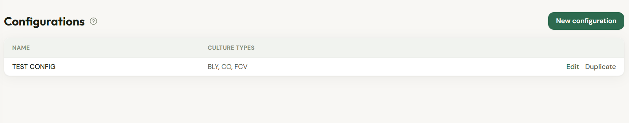
Figure 1 — Wireframe: Segmentation configurations list.

4.2 SCREEN 02: Configuration editor

4.2.1 Header — Configuration name and segments
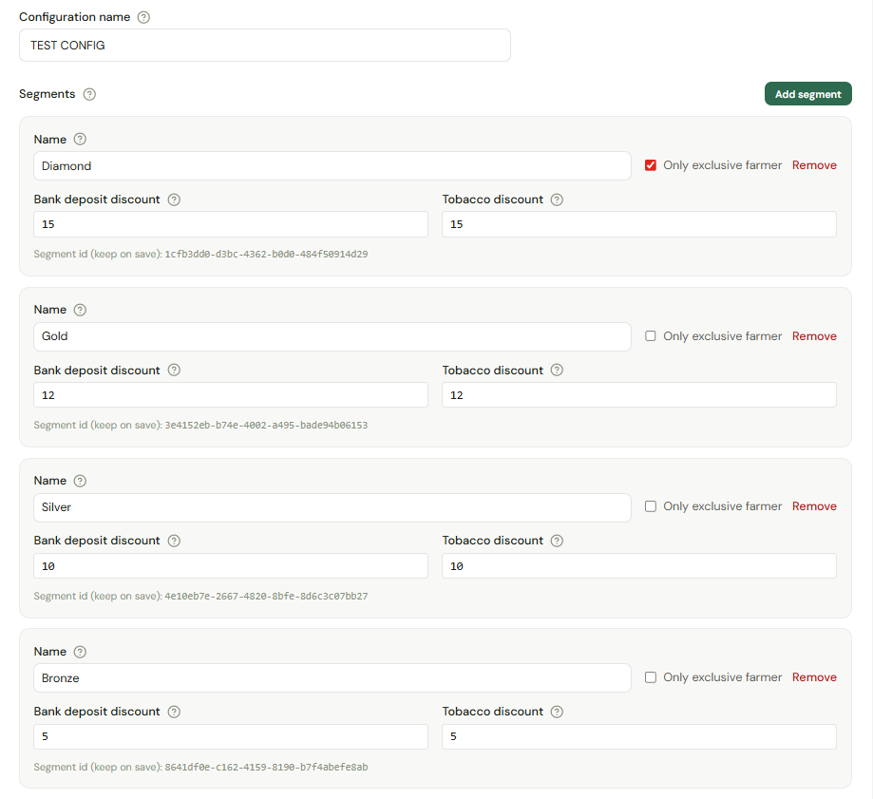
Figure 2 — Wireframe: configuration header (name and segment definitions).

- At least one segment required.
- Range min (per culture type tab): minimum total simulation score to qualify; may be negative.
- Empty range min: catch-all tier after scored thresholds.
- Only exclusive farmer: non-exclusive farmers cannot receive that segment in simulation.

4.2.2 Culture type — maximum score and segment thresholds
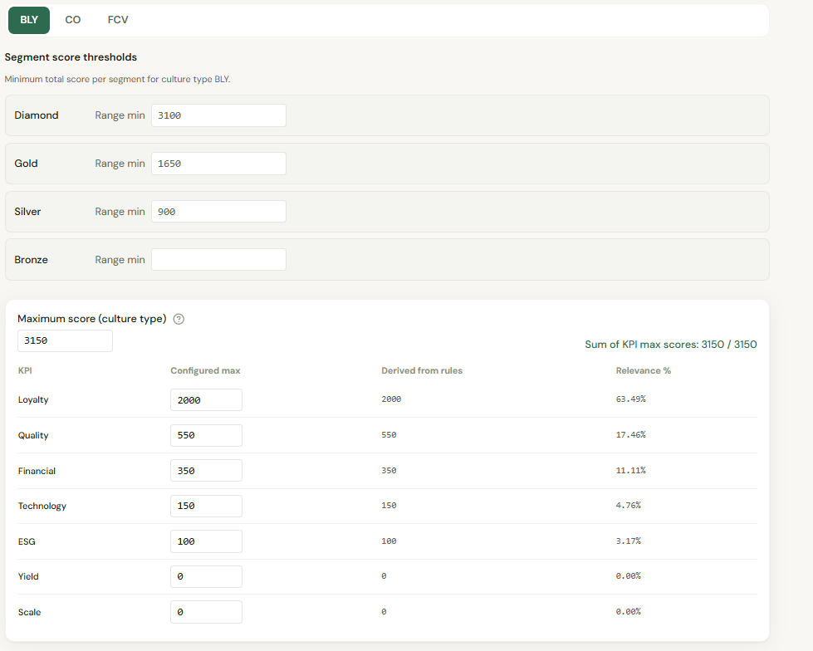
Figure 3 — Wireframe: culture type block (maximum score and segment thresholds).

4.2.3 KPI blocks per culture type
Each culture type tab contains seven KPI configuration areas. Wireframes below illustrate each KPI editor.

4.2.3.1 Loyalty
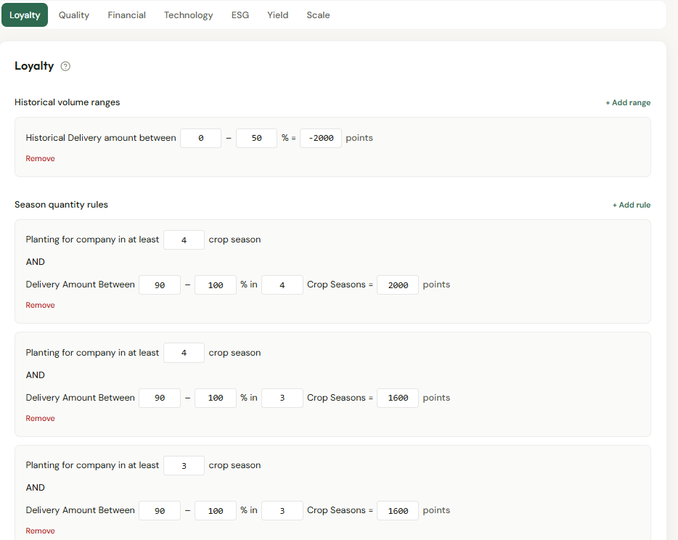
Figure 4 — Wireframe: Loyalty KPI configuration.

4.2.3.2 Quality
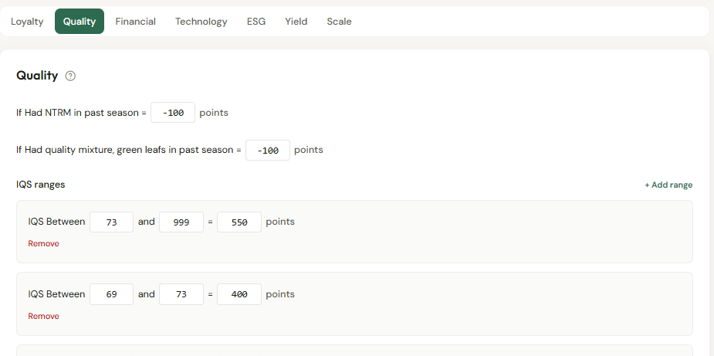
Figure 5 — Wireframe: Quality KPI configuration.

4.2.3.3 Financial
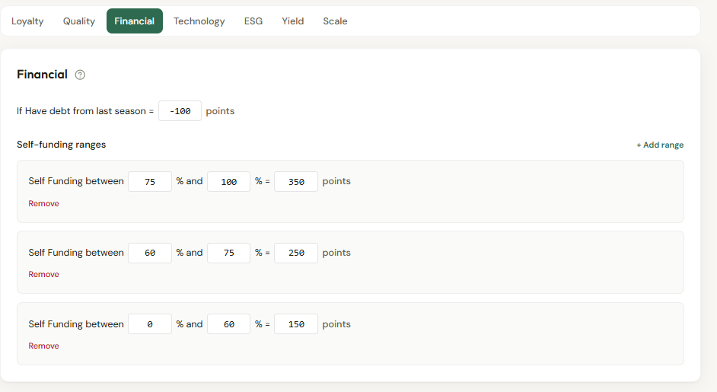
Figure 6 — Wireframe: Financial KPI configuration.

4.2.3.4 Technology
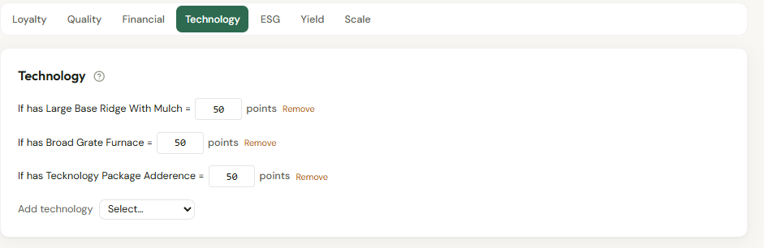
Figure 7 — Wireframe: Technology KPI configuration.

4.2.3.5 ESG
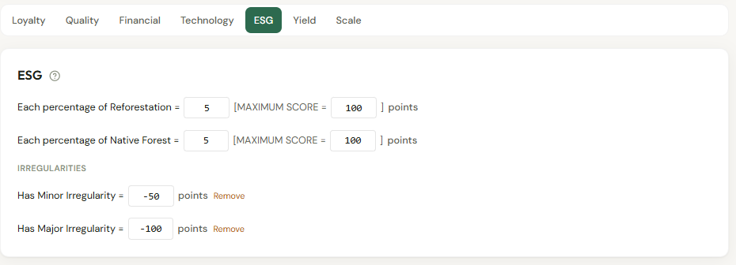
Figure 8 — Wireframe: ESG KPI configuration.

4.2.3.6 Yield
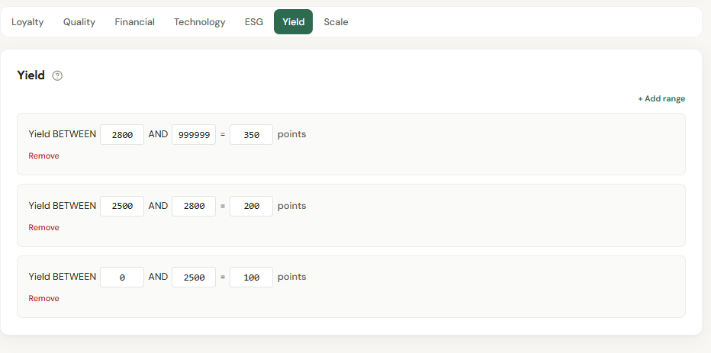
Figure 9 — Wireframe: Yield KPI configuration.

4.2.3.7 Scale
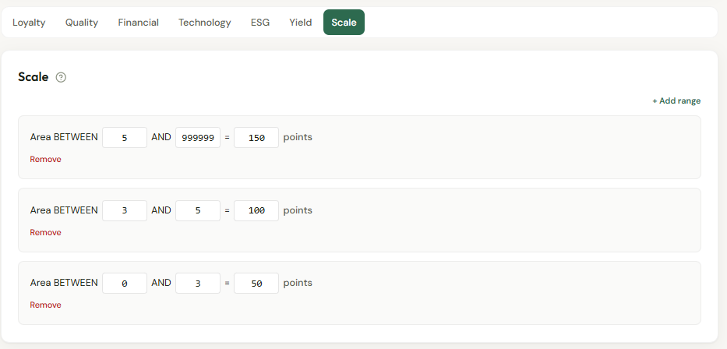
Figure 10 — Wireframe: Scale KPI configuration.

KPI block | Configuration content
Loyalty | Season-quantity rules (planting count + delivery window); historical volume on consolidated delivered %.
Quality | IQS ranges with look-back; scores for NTRM and quality mixture flags.
Financial | Self-funding % ranges; score for have-debt flag.
Technology | Score per technology from catalogue.
ESG | Reforestation/native forest points per % with caps; score per irregularity type.
Yield | Numeric yield ranges with look-back.
Scale | Numeric scale (ha) ranges with look-back.

4.3 Business rules — Save validation
- Sum of KPI max scores = culture type maximum score.
- Each KPI max score must equal derived cap from its rules (see table below).
- All seven KPI blocks required per culture type.
- At least one header segment.
KPI | Derived max score
Loyalty | Max positive season-quantity score + max positive historical volume score.
Quality | Maximum IQS range score (0 if no ranges).
Financial | Maximum self-funding range score.
Technology | Sum of positive technology scores.
ESG | Reforestation cap + native forest cap + sum of positive irregularity scores.
Yield | Maximum yield range score.
Scale | Maximum scale range score.

4.4 Loyalty precedence (simulation)
When multiple season-quantity rules match, the rule with the highest planting crop season amount wins. Consolidated delivered % uses sum of delivered kg ÷ sum of contracted kg across loyalty scope seasons — not an average of season percentages.

5. Policy & Regulatory Requirements
Restrict create/edit to Backoffice PA User. Duplicate preserves historical simulations linked to original configuration id. Discount fields may affect fiscal reporting — confirm with Finance.

6. Technical Requirements
- Culture type, technology, and irregularity catalogues for pickers.
- Full graph save under 5 seconds for typical three culture types.
- Optimistic concurrency on update (target).

7. Positive & Negative Testing
ID | Scenario | Expected result
T-01 | KPI sum ≠ maximum score | Save rejected with clear message.
T-02 | Technology max ≠ sum of tech scores | Save rejected.
T-03 | Duplicate configuration | New configuration id; rules copied.
T-04 | Valid 100-point configuration | Save succeeds.

